Day 2 -24Jan2024 Task - Answers

Difference between document and window objects

|  |  |  |
| --- | --- | --- |
| SNo | Document Object | Window Object |
| 1 | The document object represents your web page. | The window object represents your browser. |
| 2 | It’s a property of the window object. | It’s the topmost object. It is the object of the browser. |
| 3 | If you want to access any element in an HTML page, you always start with accessing the document object. | To access members inside a browser window, even outside of your webpage, window object is used. |
| 4 | All the tags, elements with attributes in HTML are part of the document | All global JavaScript objects, functions, and variables automatically become members of the window object. |
| 5 | Properties of document objects such as title, body, cookies, etc can also be accessed by a window like this window. document.title | Properties of the window object cannot be accessed by the document object. |

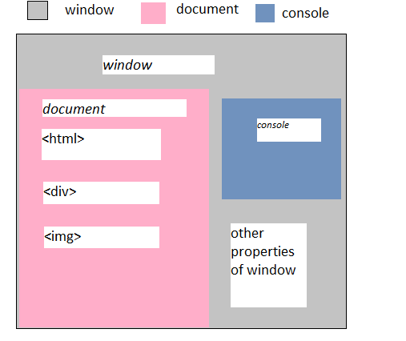

## Window Object

Whenever a window appears on the screen to display the contents of the document, the window object is created.

**Syntax:**

window.property_name;

Eg:

Window.open()

Window.console

## Document Object

The document object can be accessed with a **window.document**or just**document.**

**Syntax:**

document.property_name;

Eg:

Document.title

Document.getElementById(“name”)